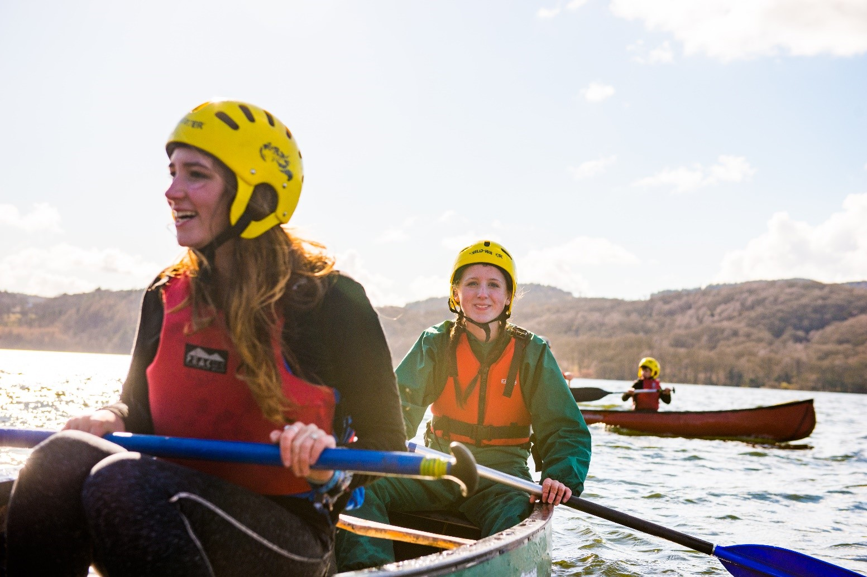

Lead the Change:

Volunteer Development Team Leader Role
Applicant Pack



About us…
Overview of Scouting
We are the UK’s biggest mixed youth organisation. We change lives by offering 4 to 25 year olds fun and challenging activities, unique experiences, everyday adventure and the chance to help others so that we make a positive impact in communities.
Scouts helps children and young adults reach their full potential. Our members gain valuable skills for life including teamwork, time management, leadership, initiative, planning, communication, self-motivation, cultural awareness and commitment. We help young people to get jobs, save lives and even change the world.

What do Scouts do?
Scouts take part in a wide range of activities as diverse as kayaking, abseiling, expeditions overseas, photography, climbing and zorbing. As a Scout you can learn survival skills, first aid, computer programming or even how to fly a plane. There’s something for everyone. It’s a great way to have fun, make friends, get outdoors, express your creativity and experience the wider world.

What do volunteers do?
This everyday adventure is only possible thanks to our team of adult volunteers, who support Scouts in a wide range of roles from working directly with young people, to helping manage a local community-based Group, to being a charity Trustee. We help volunteers get the most out of their experiences at Scouts by providing opportunities for adventure, training, fun and friendship.
Our award-winning training scheme for volunteers means that adults get as much from Scouts as young people. Our approach focuses on what you want to get out of volunteering with Scouts, while respecting how much time you can offer. Over 90% of Scout volunteers say that their skills and experiences have been useful in their work or personal life.

Key facts and figures
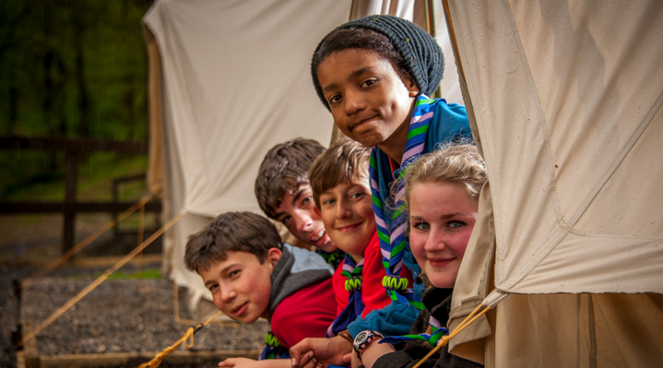
The Scout Association is a UK charity founded in 1907 and now boasts a membership of over 620,000 young people and adult leaders. We are the largest mixed youth movement in the UK. Scouting activity is delivered through 7,000-plus community-based Scout Groups nationwide.
Scouting is widely recognised and is one of the most trusted charities in the UK, giving it a significant level of influence and responsibility. Scouting’s greatest strength lies in its grass roots. It is locally that Scouting is best able to identify and work directly with young people most in need.
We believe that through the everyday adventure of Scouting, young people and adult volunteers regularly experience new challenges that enrich and change their lives

Our strategy…
By 2025 we will have prepared more young people with skills for life, supported by amazing leaders delivering an inspiring programme. We will be growing, more inclusive, shaped by young people and making a bigger impact in our communities.
Further information on our strategic objectives is provided on our website at www.scouts.org.uk


Scouting’s Fundamentals

Our mission
Scouting exists to actively engage and support young people in their personal development, empowering them to make a positive contribution to society.

Our values
As Scouts, we are guided by these values:
- Integrity
- Respect
- Care
- Belief
- Co-operation
Further information on our fundamentals, including details of our values, are provided on our website at http://Scouts.org.uk

Our key policies

In common with all members in Scouting, the Chief Commissioner of Wales is required to promote and follow our key policies. The policies cover:

- Child Protection
- Equal Opportunities
- Religion
- Safety
These policies are fully explained on our website at http://scouts.org.uk/about-us/key-policies/

About Wyre District Scouts…
Wyre District Scouts is part of West Lancashire Scout County. It is a led by the District Lead Volunteer , a District Leadership Team and governed by a Board of Trustees. Wyre District Scouts consists of 13 Scout Groups, 2 Explorer Scout Units and a Scout Network.
Number of Young People: 767
Number of Adults: 222

Introducing the leadership team roles…
We want to make volunteering easier and more fun, so that more people will want to volunteer and our current volunteers will want to stay. Doing this is how we will achieve our North Star - more young people gaining skills for life.
We want flexible volunteering to be a reality. To do this, we’re using team descriptions. Unlike role descriptions, where one volunteer takes on specific responsibilities (this can be a barrier for some volunteers joining or staying in Scouts), this approach means we can share the load among the team.
We're making it clear that volunteers can get involved with just the tasks that work for their skills, interests and free time. Teams can decide how to split the tasks up, according to who's in the team and what the local needs are.
Our new approach makes it easier for our current teams, as volunteers can give their time in a more sustainable way. It helps volunteers build knowledge, experience, and confidence. And it makes it easier for them to change their involvement when their circumstances change. As such, they stay volunteering for longer. And in the future, more volunteers will want to join Scouts and give their time as part of a flexible team.
We are now looking to recruit Team leaders for the following teams:
- The District Programme Team which supports Section programmes and District activities and events. They also help volunteers with their assessments for adventurous activity and nights away permits.
- The District Volunteering Development Team which makes sure all volunteers in District teams have a fantastic volunteering experience. By doing so, they’ll make it easy for people to join and learn new skills.

The team leaders of the above teams will also be members of the District Leadership Team which leads and inspires volunteers to give young people great experiences and skills for life. They will be involved in building and leading their own teams under the District of the District Lead Volunteer.
The District Lead Volunteer will lead the District Leadership Team and ensure that everyone is working together to achieve the same goals. They will support Group Scout Leaders and the 14-24 provision within the District and be a member of the Board of Trustees.

What leading a team means…
Each team can have at least one Team Leader. Leadership Teams are led by a Lead Volunteer and made up of other Team Leaders and Leadership Team Members. In Districts and Counties, Youth Leads are also members of the Leadership Team.
Team Leaders and Lead Volunteers work with Team Members to share tasks out and make sure the team runs smoothly.
Create a positive team environment
- Agree how Team Description tasks are shared among Team Members by considering their skills, interests, and availability.
- Make sure the team puts young people at the heart of what they do, so they can create inspiring teams and brilliant programmes.
- Make sure the team is open and inclusive and adapt team activities and tasks to be accessible to everyone.
- Make sure everyone in the team is safe and following safety and safeguarding procedures.
Help volunteers find what they need
- Help Team Members find learning and networking opportunities.
- Encourage Team Members to share what’s happening in the team and find out where they might need support.
Attract and welcome new volunteers
- Help recruit new volunteers (with the Leadership Team and Volunteering Development Team) so there’s always enough people in the team.
- Make sure new volunteers are warmly welcomed and complete their learning.
Reflect and review
- Set up regular team self-reviews (at least once a year) to give everyone a chance to reflect on successes, and plan.
- Carry out individual reviews with each Team Member. For Section Teams, they’re held by a member of the Group Leadership Team (for Squirrels, Beavers, Cubs and Scouts) or 14-24 Team (for Explorers).

District Leadership Team
Purpose
The District Leadership Team leads and inspires volunteers to give young people great experiences and skills for life. They make sure their District teams are organised, have enough volunteers, and can deliver a great programme.
Who's in the team
- District Lead Volunteer
- District Youth Lead
- Programme Team Leader
- Volunteering Development Team Leader
- Support Team Leader
- Group Lead Volunteers
- 14–24 Team Leader

Tasks for the whole team
Make sure teams across the District:
- Work well on their own (and together).
- Are inclusive and reflect the demographics of their local area.
- Have the resources, skills and enthusiasm to deliver the Scouts strategy
- Volunteers in the District’s teams have the skills and experience to fulfil their safety and safeguarding responsibilities, including by keeping up to date with changes, and being aware of safety and safeguarding concerns in the District.
- Volunteers are aware of Our Volunteering Culture, reflect on it, commit to it, and apply it in their teams.
Allocated tasks
- Help with recruitment for the District Trustee Board Chair, District Team Leaders, District Youth Lead and Group Lead Volunteer roles.
- The District Youth Lead works with teams across the District to make sure they’re shaped by young people.
Other responsibilities
Make sure safeguarding, safety and data incidents and complaints are managed well. The Lead Volunteer will be responsible for responding to these, or for appointing someone else in the District to do this.

Volunteering Development Team
Purpose
The District Volunteering Development Team makes sure all volunteers in District teams have a fantastic volunteering experience. By doing so, they’ll make it easy for people to join and learn new skills.
Who's in the team
- Volunteering Development Team Leader
- Volunteering Development Team Members
- Team Leaders of any sub-teams of the District Volunteering Development Team - eg. Awards and Recognition Sub-Team
Tasks for the whole team
Make sure all District Teams follow and reflect on Our Volunteering Culture.
Allocated tasks
Attract and welcome new volunteers to District and Group teams
- Use Scouts branded resources to attract new volunteers.
- Reply quickly and positively to possible new volunteers.
- Make sure new volunteers are welcomed easily and smoothly.
- Hold inductions with Group Lead Volunteers and other Group and District Leadership Team Members.
Make sure volunteers are well-supported
- Hold inductions with Group Lead Volunteers and other Group and District Leadership Team Members.
- Make sure all District Teams (including Group Lead Volunteers) follow our approach to safe volunteer recruitment, appointment, reviews, and processes for leaving Scouts.
Help volunteers in District teams with learning
- Help volunteers and Young Leaders find and engage in opportunities for learning and development.
- Coordinate Scouts learning that needs to be delivered by an accredited trainer – including coordinating and supporting the trainers.
- Use the learning delivery materials developed by Scouts (e.g. training sessions, workshops, activities, etc.), and make changes (when necessary) so activities are accessible for everyone.
- Help volunteers connect across the District and beyond to learn, share best practices and overcome shared challenges.
- Set up learning opportunities with external organisations (if relevant and helpful).
- Make sure volunteers can be recognised for prior learning and experience, and have it credited in their records.
- Learn from people in other Volunteering Development Teams.

Recognise volunteers
- Recognise and show appreciation for volunteers’ brilliant work, formally and informally.

How to apply

Key dates
The closing date for applications is 29th June 2025 with shortlisting and discussions with candidates to follow in early July 2025.

Process

Applications / Nomination
We will accept both self-nominations and nominations of others using this short online form:

https://forms.office.com/r/a9U5tuwJMw

Further information
For an informal discussion please contact District Lead Volunteer Jan Townley on 07866605946 or email jan.townley@westlancsscouts.org.uk

Finally
Thank you for considering a role on the District Leadership Team. This is a hugely rewarding role and we are grateful to you for taking the time to consider volunteering your time in this way.

