
Information Pack

In October 2023 we are taking a group of West Lancashire Scouts to Budapest with the aim of exploring what is a unique and amazing location, meeting local scouts, experiencing the local culture and undertake activities in the area.

Where is Budapest?
 | Budapest is the capital city of Hungary in central Europe. It is the most populated City in Hungary and is placed on the Danube river.


Why Budapest? We wanted to offer something different for the Scouts. Popular tourist destinations from the UK include France, Spain and Italy and we wanted to go somewhere where most will not have been.

When are we going? The proposed dates for the trip are 21st October until 28th October 2023. The dates will depend on flight timings and accommodation availability.

Who can go? Invested members of the scout section who are between 10 and a half and 14 years old on the date of departure can apply. We are also looking to take up to 4 young leaders with us, who would be between 14 and 17years old on the date of departure. Should we have more Scouts or Young Leaders apply, a selection event will take place. You will receive confirmation of your place before a deposit is required.
The selection event for Scouts will take place on Sunday 6th November 2022.
The selection event for Young Leaders will take place on Saturday 12th November 2022.

What can/will we do in Budapest?
The programme will be decided in the main by the Scouts and Young Leaders who are attending, subject to any risk assessments and age limits that may apply.

Activities that we have researched include a train ride to Vienna, a virtual reality theme park, exploring the city by segway and visiting the thermal bath house! Budapest is the home of the escape room so get ready to face the challenge!
What will I eat?
There will be a variety of meals cooked by ourselves, local delicacies and international fare. We will take account of any young person’s specific dietary requirements.

What will it cost?
The cost of the trip is heavily dependent on flights, cost of accommodation and the activities we want to do whilst we are there, all of which will be finalised as the trip progresses. We are setting a maximum amount and we’ll try to bring the cost down as things get more certain. The cost for the trip will not be more than £1,150. This will cover:
- Accommodation for 6 or 7 days in Budapest (dependent on flights) | 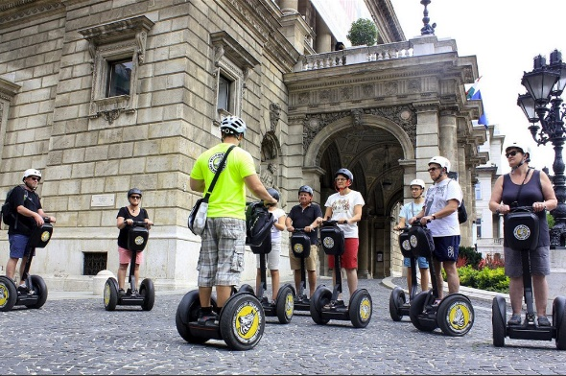
- Flight to and from Budpest
- A variety of activities based on what the participants would like to do
- All meals
- Scout Insurance
- 2 Weekend training events and training days
- Contingent polo shirt and neckerchief
To ensure no one is excluded for financial reasons, various options for financial support are available and we will help participants to organise fundraising events to help cover costs.

Payments
Two payment options are available.
Deposit payments need to be made by the end of November, using one of the methods below.
We will need a deposit of £120 (£100 for the trip plus £20 insurance). Should a place not be allocated to you, there will be a refund for the deposit.
Payments for the trip can be paid monthly or in instalments – all payments will be non-refundable.
Full payment must be made by July 2023.

Instalments
Deposit (by end of November 2022) | £120.00
Second payment (due by February 2023) | £350.00
Third payment (due by April 2023) | £350.00
Fourth payment (due by July 2023) | £330.00

Monthly payments
£1,150 - £120 deposit = £1,030
8 monthly instalments of £128.75, starting December 2022.
All payments should be made online quoting your child’s name as the reference.

How to pay
The bank details are-  Account Name: West Lancs Scout Events  Sort code: 16-28-33  Account number: 10106137 | Payments can also be made through the West Lancs Shop: https://www.westlancsscouts.org.uk/shop/

Want to apply?
If you are a Scout and would like to join us on this once in a life time opportunity, please complete in the application form, which can be accessed here. Please complete by Friday 28th October 2022.
If you want to apply to be a young leader, there is a different form, found in the same locations as above. Please complete by Friday 28th October 2022.
Further Information
If you require any further information or
have any questions please contact Nichola Bonsor.
Email - nikki.bonsor@westlancsscouts.co.uk
Mob - 07751234508
West Lancs Website http://www.westlancsscouts.org.uk/majorevents/
Facebook page – WLSGoBudapest2023

Sample Itinerary
All activities are subject to change based on availability of activities, accommodation and flight times.
Day | Activity
Saturday 21st October 2023 | Travel – arrive in Budapest  Visit to campsite and meet local Scouts
Sunday 22nd October 2023 | Day at Scout Campsite
Monday 23rd October 2023 | Move to city and set up in Youth Hostel  Explore city by segway and visit escape room
Tuesday 24th October 2023 | Activities in city using Budapest card including castle visits and a funicular trip.
Wednesday 25th October 2023 | Activities in city using Budapest card including chain bridge and a river tour.
Thursday 26th October 2023 | Visit virtual reality games park  Visit to Szechenyi Baths (thermal bath house)
Friday 27th October 2023 | Potential trip to Vienna
Saturday 28th October 2023 | Return to airport and travel home.

Meet the Leadership Team
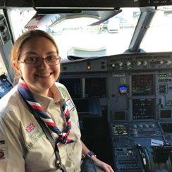 | Nichola Bonsor – Contingent Leader
 | Hi, I’m Nichola Bonsor. I am 38 and I have been a Scout Leader since I was 17, mainly working in the Cub section. In recent years I have enjoyed various international trips with Explorer and Network sections venturing to Poland in 2016, Iceland in 2017 and Finland in 2018. I am also a Group Scout Leader and part of the Cub District Team in Blackpool. I am looking forward to taking a group of Scouts to Budapest next year.
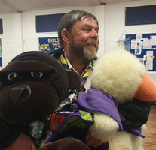 | Jim Mayes
 | Hi, I’m Jim. I joined scouting as an Assistant Cub Leader at 2nd Exeter Scout Group over a decade ago. I took over running their Scout troop in 2012 and took them on international trips to France, Holland and Switzerland. In March 2018, I moved to Lancaster and joined 34th Lancaster Scouts as a Scout Leader soon afterwards. You may have seen me running fencing sessions at Red Rose or West Lancs (especially Lonsdale District). This is my second International trip with West Lancashire.
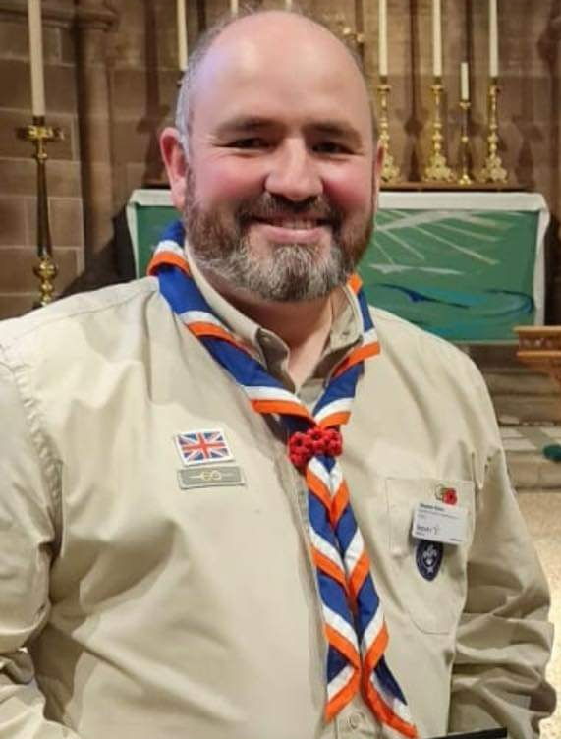 | Stephen Chow  Hi I’m Stephen and I have been a leader for over 10 years. Through Scouting, I have had the opportunity to go to Romania, Austria, Uganda and the Menin Gate and I can’t wait to share a further international trip with a new group of Scouts.
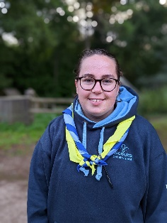
Jess Watson
Hi I'm Jess, I'm a leader with 2nd Kirkham and at 1st Bramhall in Manchester whilst I'm at university. I've been in scouting over 10 years and have been a climbing instructor for 6 years. I'm excited to meet you all for an amazing trip!
Harriet Clark
I am currently an explorer scout at Mungo Park ESU and a Scout Young Leader at 1st Broughton Scout Group, both in Preston, but will be a leader on this trip. During the 10 years I have been involved in Scouting I have been to Switzerland and Scotland on international camps, and I am looking forward to exploring Budapest with a fantastic group of young people.

